SIMATS ENGINEERING
ASSESSMENT TOOL 1

COURSE NAME: Database Management Systems
COURSE CODE: CSA0501

COURSE OUTCOME COVERED

CO1: Analyze DBMS architecture, different data models, schema types, and design ER/EER diagrams, relational schemas for case-based scenarios by identifying entities and relationships. (BL1, BL2)

Activity Tool : Short Answer Text(High)
Assessment Tool Weightage: 30%

Dr

QUESTIONS Total Marks: 50
Q.No | Question | Bloom's Level | Marks
1 | UPS Product Tracking Information System  UPS prides itself on having up-to-date information on the processing and current location of each shipped item. To do this, UPS relies on a company-wide information system. Shipped items are the heart of the UPS product tracking information system. Shipped items can be characterized by item number (unique), weight, dimensions, insurance amount, destination, and final delivery date. Shipped items are received into the UPS system at a single retail center. Retail centers are characterized by their type, uniqueID, and address. Shipped items make their way to their destination via one or more standard UPS transportation events (i.e., flights, truck deliveries). These transportation events are characterized by a unique scheduleNumber, a type (e.g, flight, truck), and a deliveryRoute. Create an Entity Relationship diagram that captures this information about the UPS system. | BL1 – Remember | 5
2 | Course Management System  Consider a university database for the scheduling of classrooms for final exams. This database could be modeled as the single entity set exam, with attributes course-name, section-number, room-number, and time. Alternatively, one or more additional entity sets could be defined, along with relationship sets to replace some of the attributes of the exam entity set, as  • course with attributes name, department, and c-number  • section with attributes s-number and enrollment, and dependent as a weak entity set on course  • room with attributes r-number, capacity, and building  Show an E-R diagram illustrating the use of all three additional entity sets listed. | BL2 – Understand | 5
3 | University Registrar’s Office Management System  A university registrar’s office maintains data about the following entities:  - courses, including number, title, credits, syllabus, and prerequisites;  - course offerings, including course number, year, semester, section number, instructor(s), timings, and classroom;  - students, including student-id, name, and program;  - instructors, including identification number, name, department, and title.  - Further, the enrollment of students in courses and grades awarded to students in each course they are enrolled for must be appropriately modeled.  Construct an E-R diagram for the registrar’s office. | BL2 – Understand | 5
4 | Hospital Management System  Construct an E-R diagram for a hospital with a set of patients and a set of medical doctors.  Associate with each patient a log of the various tests and examinations conducted. Construct appropriate tables for the above ER Diagram :  Patient(SS#, name, insurance)  Physician ( name, specialization)  Test-log( SS#, test-name, date, time)  Doctor-patient (physician-name, SS#)  Patient-history(SS#, test-name, date) | BL2 – Understand | 5
5 | Company Project Management System  Construct an ER Diagram for Company having following details :  Company organized into DEPARTMENT. Each department has unique name and a particular employee who manages the department. Start date for the manager is recorded. Department may have several locations.  • A department controls a number of PROJECT. Projects have a unique name, number and a single location.  • Company’s EMPLOYEE name, ssno, address, salary, sex and birth date are recorded. An employee is assigned to one department, but may work for several projects (not necessarily controlled by dept). Number of hours/week an employee works on each project is recorded; The immediate supervisor for the employee.  • Employee’s DEPENDENT are tracked for health insurance purposes (dependentname, birthdate, relationship to employee). | BL2 – Understand | 5
6 | Explain schema and instance with examples. Distinguish between logical schema, physical schema, and view schema. | BL1 – Remember | 5
7 | Identify the entities, attributes, and relationships for a Bank Management System and construct its ER diagram. | BL2 – Understand | 5
8 | Explain the Extended ER (EER) model. Describe the concepts of generalization, specialization, and aggregation. | BL2 – Understand | 5
9 | Design an EER diagram for a Hospital Management System incorporating inheritance and weak entities. | BL2 – Understand | 5
10 | Explain the role of a DBA (Database Administrator) and the responsibilities associated with the position. | BL1 – Remember | 5

Code of Conduct:

I __K.Tejaswi(192525407)_ (Name / Reg No) certify that this submission is my original work and that I have adhered to the guidelines specified for this assessment.
I understand that any violation of academic integrity rules will result in disciplinary action.

Signature of the student:

RUBRICS FOR CALCULATION:

Criteria | Weightage | Level 4 (Exemplary) | Level 3 (Proficient) | Level 2 (Developing) | Level 1 (Beginning)
Concept Identification | 30% | Demonstrates  clear and  complete  understanding of  the concept | Good  understanding  with minor  gaps | Basic  understanding  with some  misconceptions | Poor or  incorrect  understandin  g
Linkages | 25% | Completely  correct answer  with no errors | Mostly correct  with minor  errors | Partially correct  with noticeable  errors | Incorrect or  irrelevant  answer
Organization | 20% | Correctly applies  concepts to solve  the  question/problem | Applies  concepts with  minor  mistakes | Limited or  partially correct  application | No or  incorrect  application
Integration of Literature | 15% | Covers all  required parts of  the question | Covers most  parts with  minor  omissions | Covers only  some parts | Incomplete  or missing  response
Clarity | 10% | Clear, concise,  and well-  organized answer | Understandabl  e with minor  issues | Somewhat  unclear or poorly  structured | Difficult to  understand

- Ans . UPS product tracking er diagram

- Entities and attributes

Shipped_item :
- Itemnumber(pk)-unique id
- Weight
- Dimensions
- Insuranceamount
- Destination
- Finaldeliverydate

Retail_center :
- Uniqueid(pk)
- Type
- Address
Transport_event
- Schedulenumber (pk)
- Type (flight / truck)
- Deliveryroute

- Relationships

Received_at
- Between: shipped_item → retail_center
- Meaning: each item is received at one retail center
- Cardinality:
many shipped_items → one retail_center

Transported_via
- Between: shipped_item ↔ transportation_event
- Meaning: items travel through multiple transport events
- Cardinality:
many-to-many (m:n)

ER Diagram :
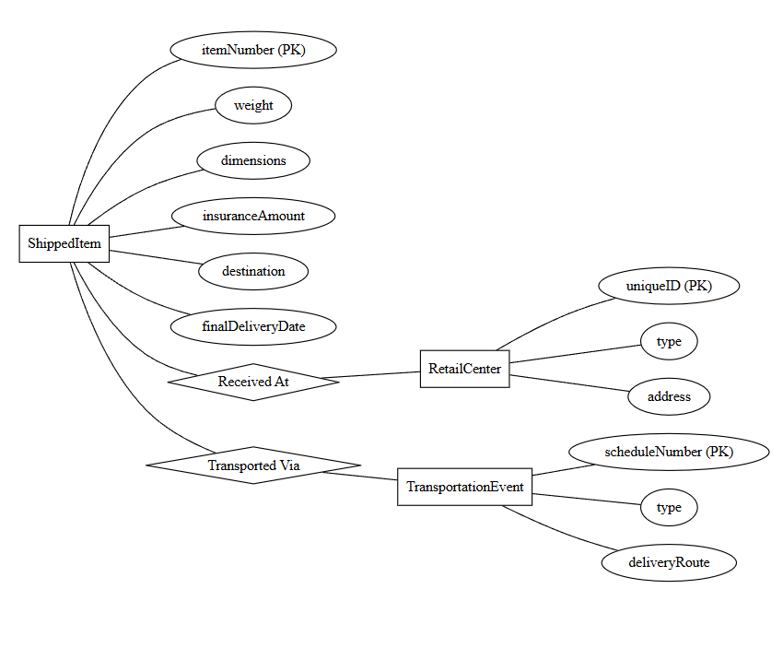

2.Ans: Course Management System

Entity sets & attributes
- Course (strong entity set)
  - Attributes: c-number (primary key), name, department
- Section (weak entity set dependent on course)
  - Attributes: s-number (partial key / discriminator), enrollment
  - Primary key: formed by combining course.c-number + section.s-number
- Room (strong entity set)
  - Attributes: r-number, building, capacity
  - Primary key: composite key (building, r-number), as room numbers are typically unique only within a given building.
- Exam (relationship set or weak/associative entity)
  - Since an exam ties together a specific course section, a specific room, and a specific time slot, it can be modeled as a relationship connecting section and room, with time as a descriptive attribute of the relationship/event.
Key relationships & cardinalities
- Has_sec (identifying relationship between course and section)
  - Cardinality: $1:M$(one course can have multiple sections; a section belongs to exactly one course).
  - Existence dependency: section cannot exist without a course. Double rectangles/diamonds represent weak entity structures.
- Located_in / scheduled_for (connecting section, room, and exam)
  - Section to exam ($1:M$): a section has one primary final exam slot, but a room can host multiple exams across different times.
  - Room to exam ($1:M$): a room can host many exams throughout the exam period, but a given section's exam occurs in one room at a given time.

ER-Diagram :

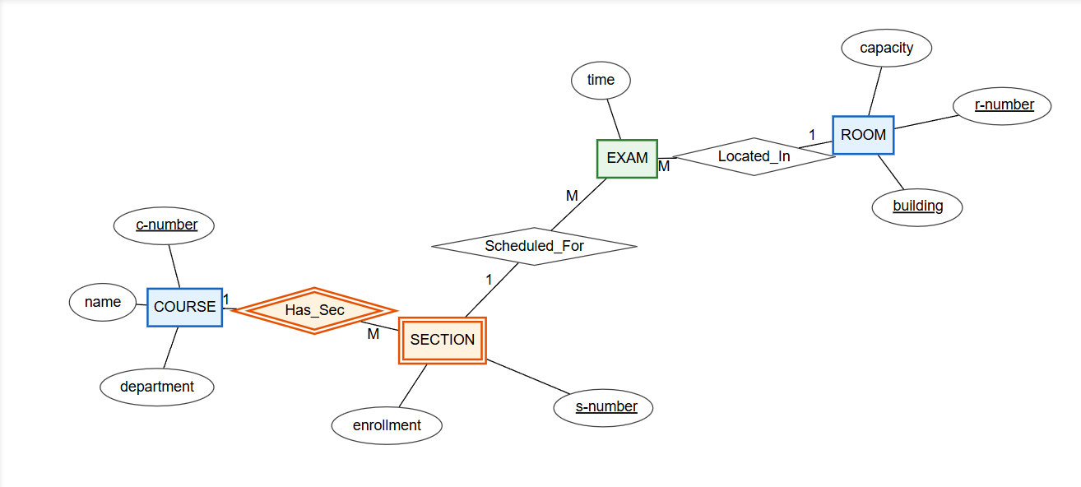

3.Ans : University Registrar’s Office Management System

Entity-relationship

- Course (strong entity)
  - Key: number
  - Attributes: title, credits, syllabus
  - Recursive relationship (prerequisites): a course can have zero or more prerequisite courses.
- Course_offering (weak entity dependent on course)
  - Partial key: section_number
  - Attributes: year, semester, timing, classroom
- Student (strong entity)
  - Key: student_id
  - Attributes: name, program
- Instructor (strong entity)
  - Key: emp_id
  - Attributes: name, department, title
- Enrollment (relationship / associative entity between student and course_offering)
  - Descriptive attribute: grade

ER-Diagram :

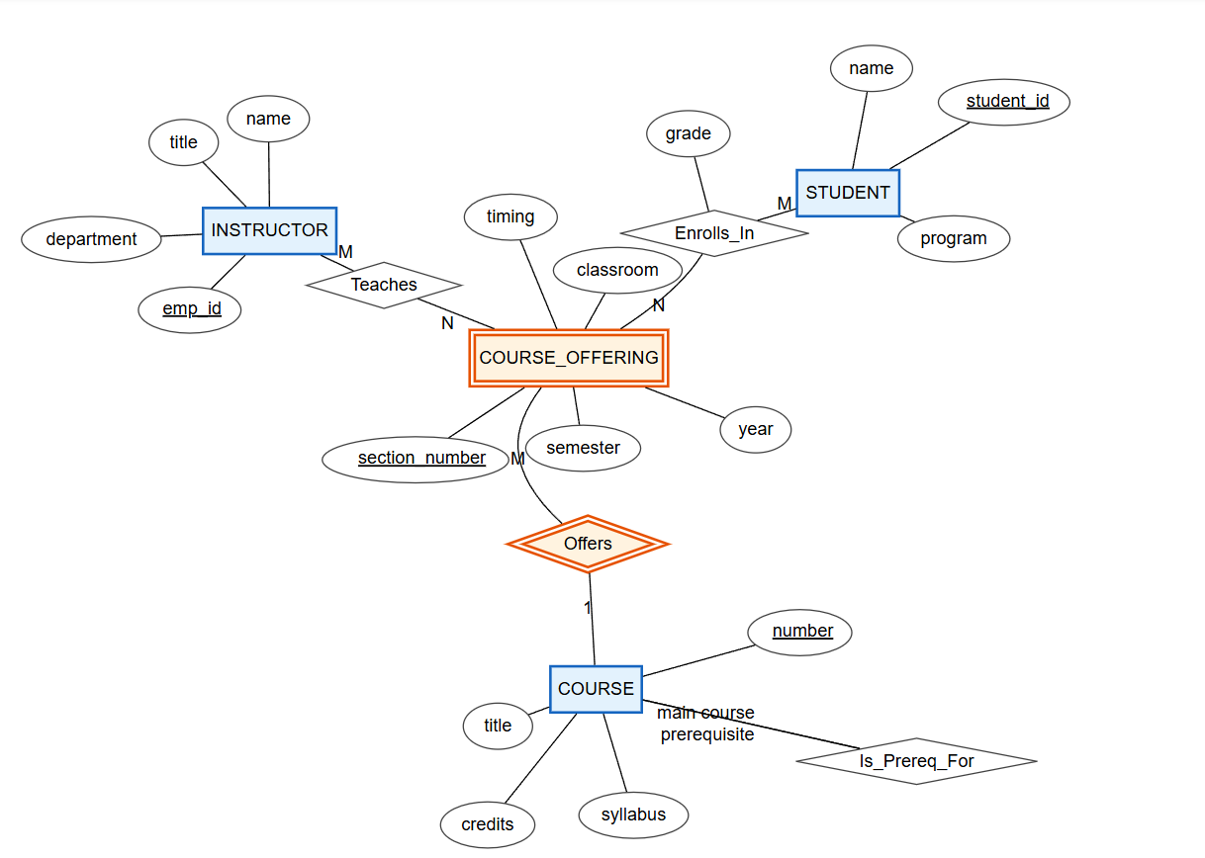

4.Ans: Hospital Management System

Entities and Attributes
1. Patient
- Attributes: SS# (Primary Key), Name, Insurance
- Each patient is uniquely identified by SS#.
2. Physician
- Attributes: Name (Primary Key), Specialization
- Represents doctors working in the hospital.
3. Test-Log
- Attributes: SS#, Test-Name, Date, Time
- Stores details of tests conducted for patients.
4. Patient-History
- Attributes: SS#, Test-Name, Date
- Maintains past medical records of patients.
Relationships
1. Doctor–Patient Relationship
- A physician can treat many patients and a patient can be treated by many physicians
Many-to-Many (M:N) relationship
2. Patient–testlog Relationship
- One patient can have multiple test records
One-to-Many (1:M) relationship
3. Patient–History Relationship
- One patient can have multiple history records
One-to-Many (1:M) relationship

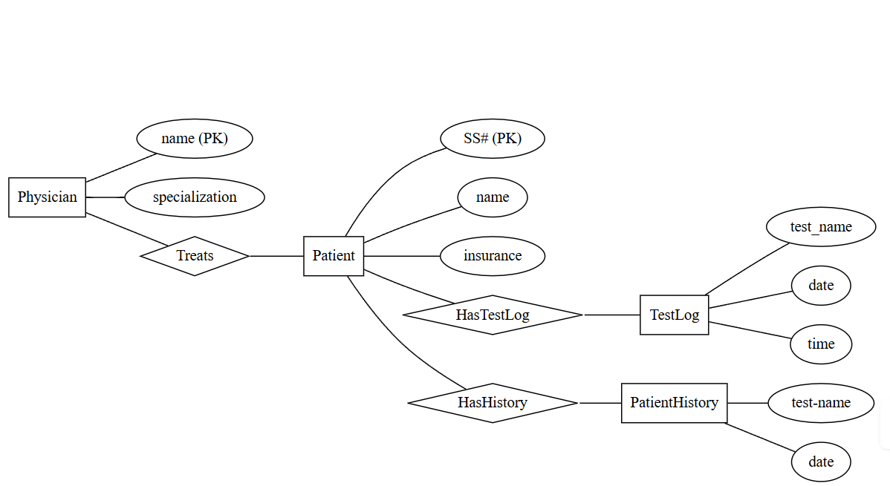

5 Ans : Company Project Management System

Entities and Attributes
1. Department
- Attributes: Dept_Name (Primary Key), Locations
- Each department has a unique name and may have multiple locations.
2. Employee
- Attributes: SSN (Primary Key), Name, Address, Salary, Sex, birthdate
- Each employee works in one department.
3. Project
- Attributes: Project_Name, Project_Number (Primary Key), Location
- Each project is controlled by one department.
4. Dependent
- Attributes: Dependent_Name, birthdate, Relationship
- Dependents are associated with employees for insurance purposes.
Relationships
1. Manages (Employee–Department)
- Each department is managed by one employee
- Manager’s start date is recorded
1:1 relationship
2. Works_For (Employee–Department)
- An employee works for one department
- A department has many employees
1:M relationship
3. Controls (Department–Project)
- A department controls multiple projects
- Each project belongs to one department
1:M relationship
4. Works_On (Employee–Project)
- An employee can work on multiple projects
- A project can have multiple employees
- Attribute: Hours per week
M:N relationship
5. Supervision (Employee–Employee)
- One employee supervises others
1:M recursive relationship
6. Dependent Of (Employee–Dependent)
- An employee can have multiple dependents
1:M relationship

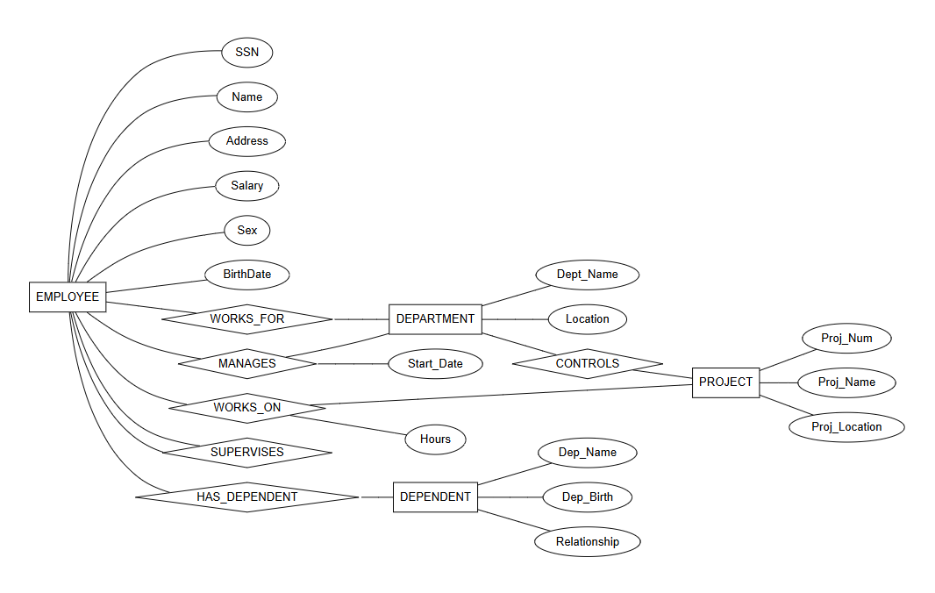

6.Ans : Schema and Instance

Schema
A schema is the logical structure or design of a database. It specifies how the data is organized, including tables, attributes, and relationships.
It acts as a blueprint of the database
It is defined once and changes rarely
Example:
Schema of a student table:
Student(SID, Name, Age, Course)
🔹 Instance
An instance is the actual data stored in the database at a specific point in time.
It is also called a snapshot of the database
It changes frequently as data is inserted, deleted, or updated
Example:
SID | Name | Age | Course
101 | Ravi | 20 | CSE
102 | Anu | 21 | ECE
Difference Between Schema and Instance
Schema | Instance
Structure/design of database | Actual data stored
Static (rarely changes) | Dynamic (changes often)
Defined using DDL | Modified using DML
Blueprint | Snapshot
Types of Schema
1. 🔹 Logical Schema
The logical schema describes the overall structure of the database, such as entities, attributes, and relationships. It does not deal with physical storage.
Example:
Student(SID, Name, Age)
Course(CID, Title)
Enrollment(SID, CID)
2. 🔹 Physical Schema
The physical schema describes how the data is actually stored in the system, including file organization and indexing.
Example:
- Data stored in files on disk
- Index created on SID
- Use of B+ trees or hashing

3. 🔹 View Schema (External Schema)
The view schema defines how different users view the database. It shows only required data and hides the rest.
Example:
CREATE VIEW Student_View AS
SELECT Name, Course FROM Student;
Key Differences
Schema Type | Description | Level
Logical Schema | Overall structure of database | Design level
Physical Schema | Storage details | Internal level
View Schema | User-specific view | External level
Conclusion
Schema represents the design of the database, while instance represents the actual data. The three types of schemas—logical, physical, and view—help achieve data abstraction, security, and independence in DBMS.

7.Ans : Bank Management System

1. Entities and Attributes
1. Customer
Represents bank customers.
Attributes:
- Customer_ID (Primary Key)
- Name
- Address
- Phone
- Email
2. Account
Represents bank accounts.
Attributes:
- Account_No (Primary Key)
- Account_Type (Savings/Current)
- Balance
- Open_Date
3. Branch
Represents bank branches.
Attributes:
- Branch_ID (Primary Key)
- Branch_Name
- Location
4. Loan
Represents loans issued by the bank.
Attributes:
- Loan_ID (Primary Key)
- Loan_Type
- Amount
- Interest_Rate
5. Transaction
Represents account transactions.
Attributes:
- Transaction_ID (Primary Key)
- Date
- Amount
- Type (Deposit/Withdrawal)
2. Relationships
1. Customer – Account
- A customer can have multiple accounts
- An account can belong to one or more customers (joint account)
Relationship: Depositor
2. Account – Transaction
- One account can have many transactions
Relationship: Performs
3. Branch – Account
- A branch manages multiple accounts
Relationship: Maintains
4. Customer – Loan
- A customer can take multiple loans
Relationship: Borrower
5. Branch – Loan
- A branch issues many loans
Relationship: Issues

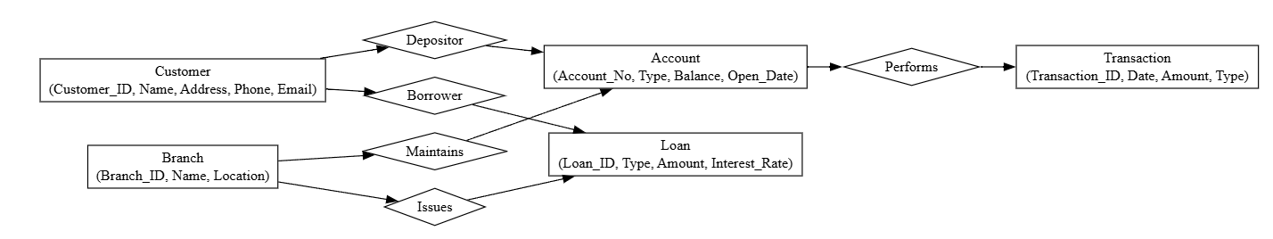

8.Ans: Extended ER (EER) Model

1. Generalization
Definition:
Generalization is a bottom-up approach in which two or more similar entities are combined into a single higher-level entity (superclass) based on their common features.
Example:
Savings Account and Current Account can be generalized into a single entity called Account.
Key Points:
- Combines common attributes into one entity
- Reduces redundancy
- Forms a superclass-subclass hierarchy
2. Specialization
Definition:
Specialization is a top-down approach where a higher-level entity is divided into subclasses based on distinguishing characteristics.
Example:
An Employee entity can be specialized into Manager and Clerk.
Key Points:
- Creates subclasses from a parent entity
- Subclasses inherit attributes of the parent
- Can be:
  - Disjoint or Overlapping
  - Total or Partial participation
3. Aggregation
Definition:
Aggregation is a concept where a relationship is treated as an entity so that it can participate in another relationship.
Example:
The relationship “Employee works on Project” can be aggregated and related to Manager.
Key Points:
- Represents relationships between relationships
- Helps model complex real-world scenarios
- Improves abstraction
Conclusion
The EER model extends the basic ER model by introducing generalization, specialization, and aggregation, making it more powerful for designing complex databases. It allows better representation of real-world systems and supports structured and efficient database design.

9.Ans : EER Diagram for Hospital Management System

1. Main Entities and Attributes
Hospital
- Hospital_ID (PK)
- Name
- Location
Person (Superclass)
- Person_ID (PK)
- Name
- Address
- Phone
2. Inheritance (Specialization)
The entity Person is specialized into:
Patient (Subclass of Person)
- Patient_ID
- Disease
- Admission_Date
Doctor (Subclass of Person)
- Doctor_ID
- Specialization
- Salary
3. Other Strong Entities
Department
- Dept_ID (PK)
- Dept_Name
Room
- Room_No (PK)
- Type
- Charges
4. Weak Entity
Appointment (Weak Entity)
- Appointment_Date
- Time
Depends on:
- Patient
- Doctor
Primary Key: (Patient_ID, Doctor_ID, Date, Time)
Cannot exist without Patient and Doctor
5. Relationships
- Hospital has Department (1:M)
- Department employs Doctor (1:M)
- Patient admitted_to Room (M:1)
- Doctor treats Patient (M:N)
- Patient & Doctor have Appointment (Identifying relationship for weak entity)

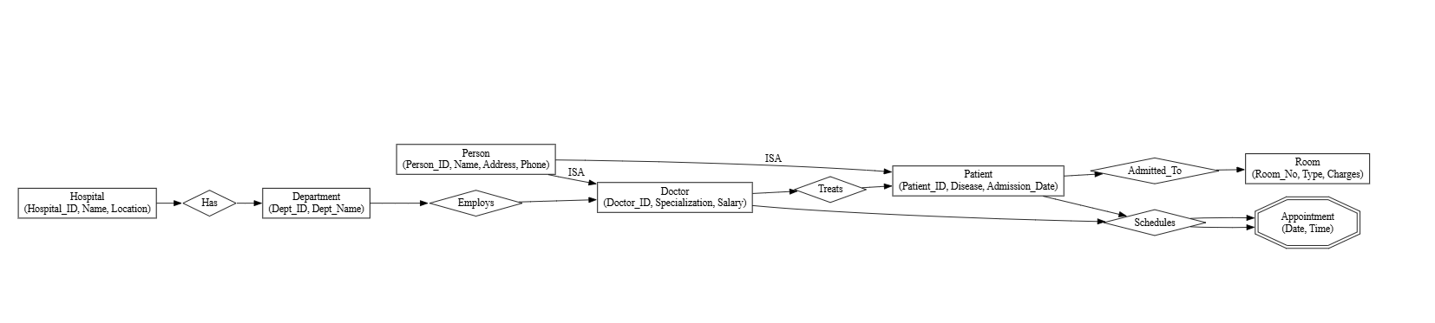

10.Ans : Role of a DBA

A Database Administrator (DBA) is a person responsible for managing, maintaining, and securing an organization’s database systems. The DBA ensures that data is available, secure, consistent, and efficiently stored so that users and applications can access it without problems.
Key Responsibilities of a DBA
1. Database Design and Implementation
- Designs the database structure (schema) based on requirements
- Defines tables, relationships, constraints, and indexes
- Ensures proper organization of data
2. Installation and Configuration
- Installs database software such as mysql, Oracle, or SQL Server
- Configures settings for optimal performance
- Sets up database environments
3. Security Management
- Controls user access and permissions
- Protects data from unauthorized access
- Implements authentication and encryption methods
4. Backup and Recovery
- Takes regular data backups
- Restores data in case of failure or loss
- Plans disaster recovery strategies
5. Performance Monitoring and Tuning
- Monitors database performance
- Optimizes queries and indexing
- Ensures fast and efficient data retrieval
6. Data Integrity Maintenance
- Ensures accuracy and consistency of data
- Enforces constraints and validation rules
- Prevents data corruption
7. Troubleshooting and Maintenance
- Identifies and resolves database issues
- Performs regular updates and maintenance
- Ensures system reliability
8. Storage and Capacity Planning
- Manages disk space and storage
- Plans for future data growth
- Ensures scalability
Conclusion
The DBA plays a crucial role in database systems by ensuring security, performance, reliability, and availability of data. Without a DBA, managing large and complex databases would be difficult and inefficient.

